**Practical No 2**

**Aim:** Write a program to do the following:

a. Enter a vector u as a n-list

b. Enter another vector v as n-list

c. Find the vector au+bv for different values of a and b

d. Find the dot product of u and v

**Source Code:**

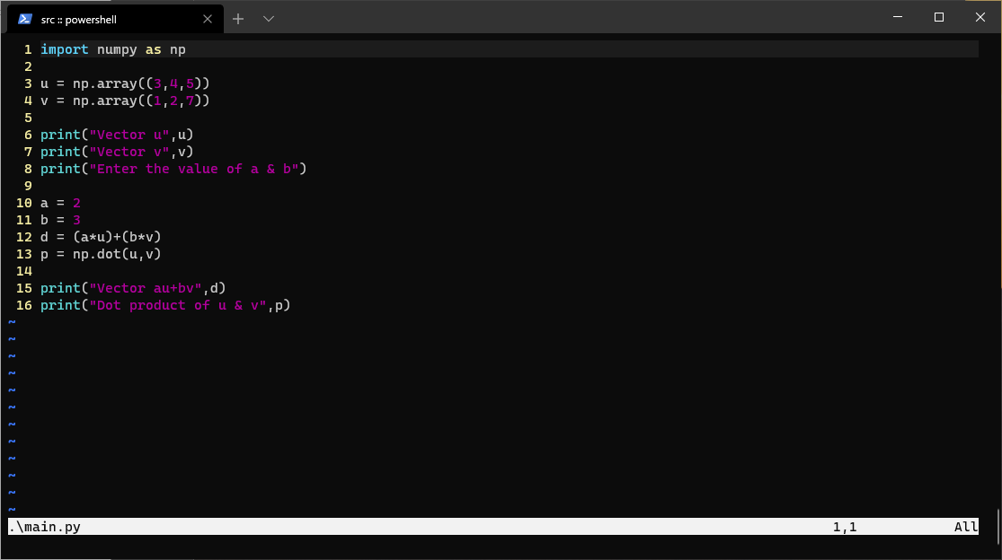

**Output:**

